Supporting Information

Interface-Engineered MXene/Layered Double Hydroxide Heterostructure
for Dopamine Sensing

Ayush Gadpayle,^{1,5,6} Hemil Marviya,¹ Yi Yang,¹ , Jean G. A. Ruthes,^{5,6} Peter Rolf Burger,^{5,6} Krutarth Kamath,¹ Volker Presser,^{5,6,7} Babak Anasori,^{1,3} Arun Kumar Mannodi¹ and Lia Stanciu^{1,2,4*}

- School of Materials Engineering, Purdue University, 701 West Stadium Ave., West Lafayette, IN, 47907, USA
- School of Biomedical Engineering, Purdue University, 206 S Martin Jischke Dr, West Lafayette, IN, 47907, USA
- School of Mechanical Engineering, Purdue University, 701 West Stadium Ave., West Lafayette, IN, 47907, USA
- Bindley Bioscience Center, Purdue University, 1203 W State St, West Lafayette, IN, 47907, USA
- INM - Leibniz Institute for New Materials, D2 2, 66123, Saarbrücken, Germany
- Department of Materials Science & Engineering, Saarland University, Campus D2 2, 66123, Saarbrücken, Germany
- saarene, Saarland Center for Energy Materials and Sustainability, Campus C4 2, 66123 Saarbrücken, Germany

* Corresponding authors’ email: lstanciu@purdue.edu (L. Stanciu)

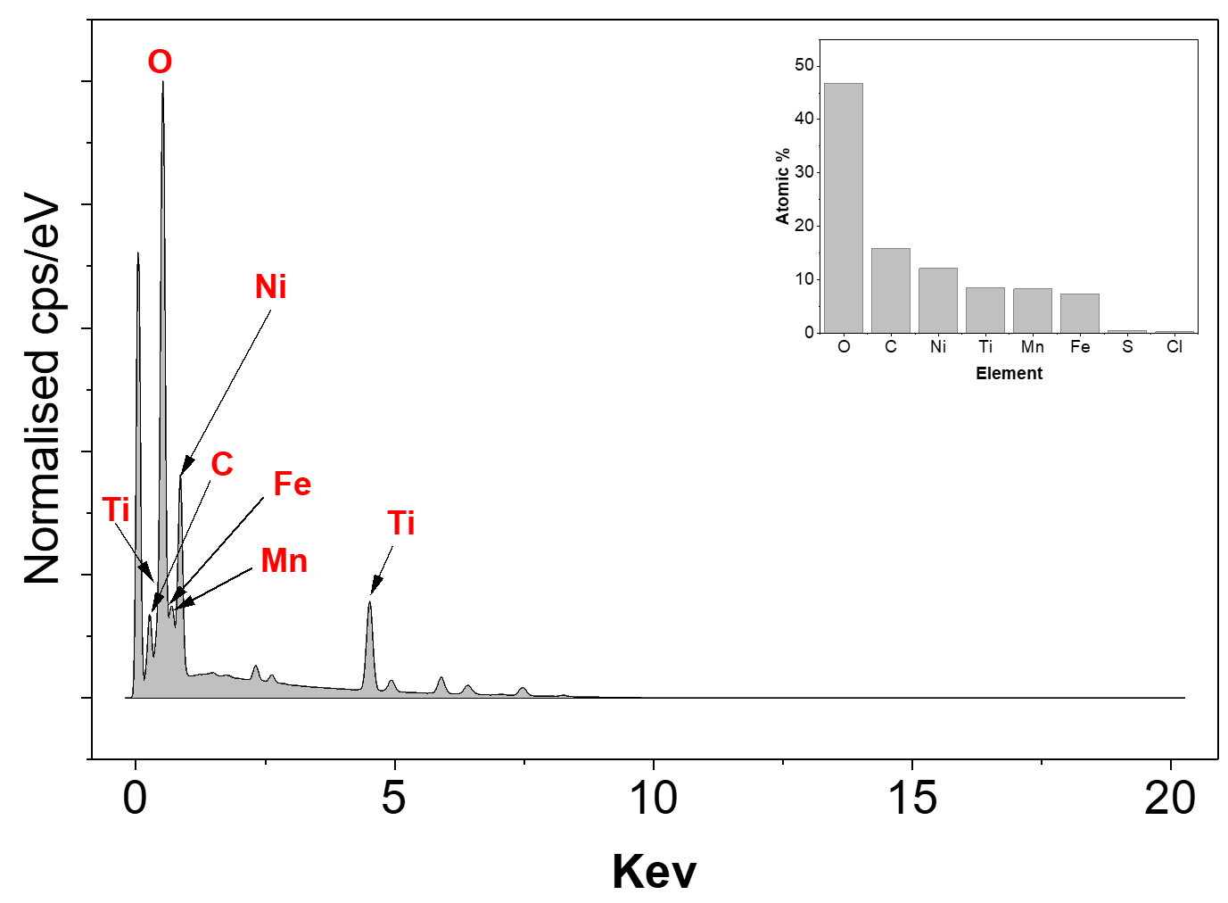
Figure S1. EDX elemental spectrum of NFM-MX.

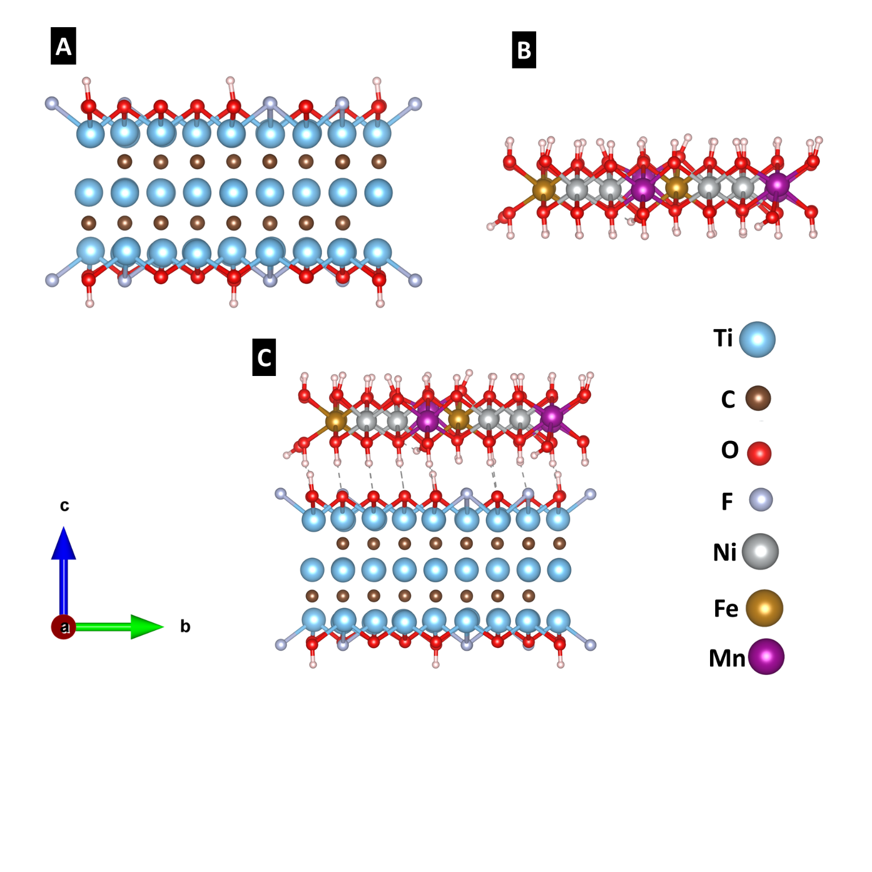
Figure S2: Schematic of atomic models of (A) Ti₃C₂T_{x} MXene (MX) (B) Ni₂FeMn-LDH (NFM) (C) NFM-MX

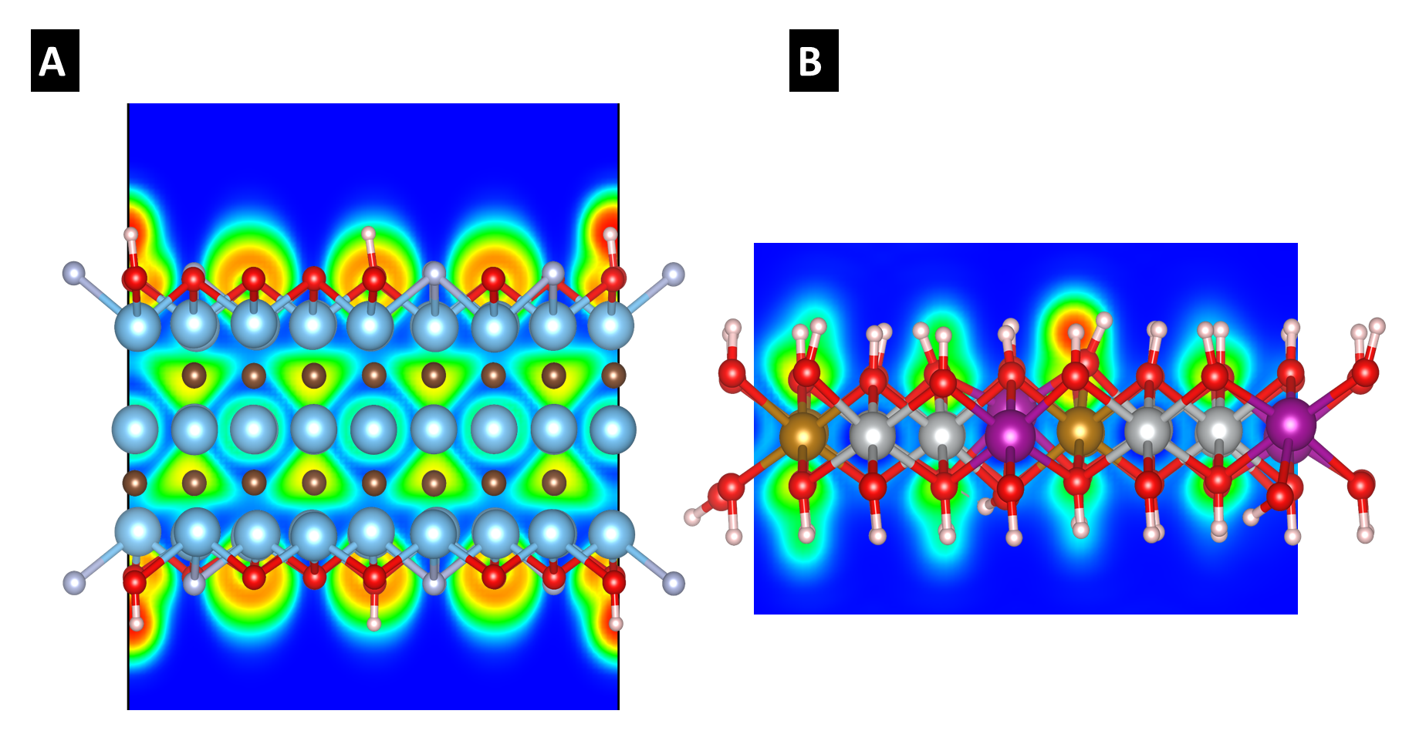
Figure S3. ELF plot of (a) Ti₃C₂T_{x} (MX), (b) Ni₂FeMn-LDH (NFM)

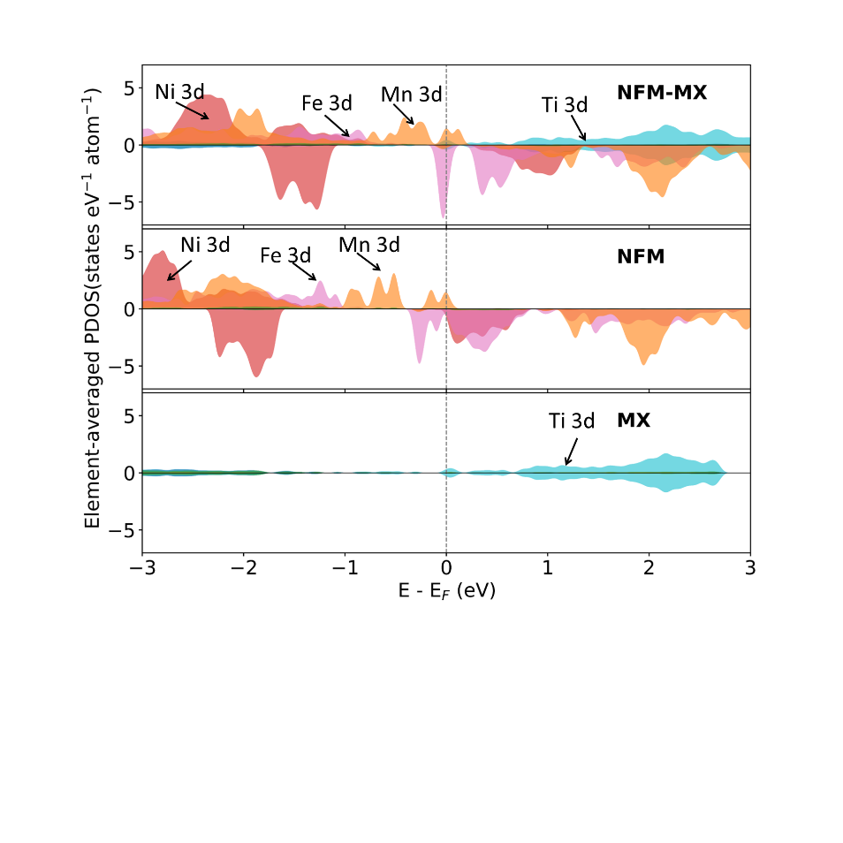
Figure S4. PDOS of NFM-MX

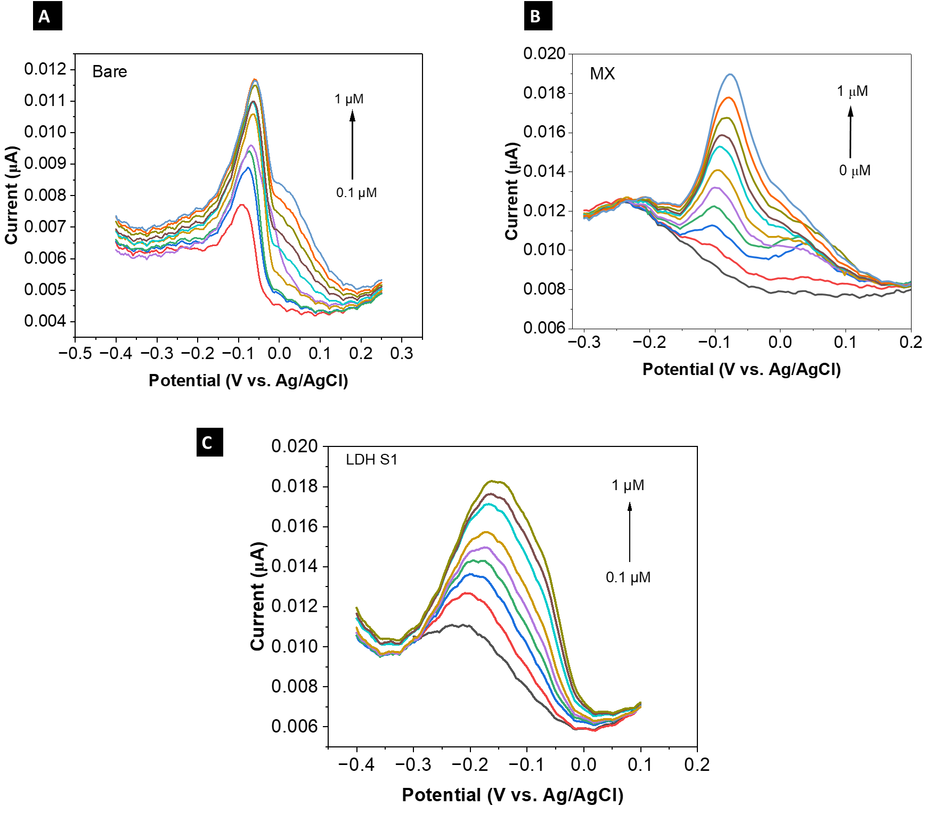

Figure S5. DPV plot of (A) Bare SPE (B) MX (C) NFM

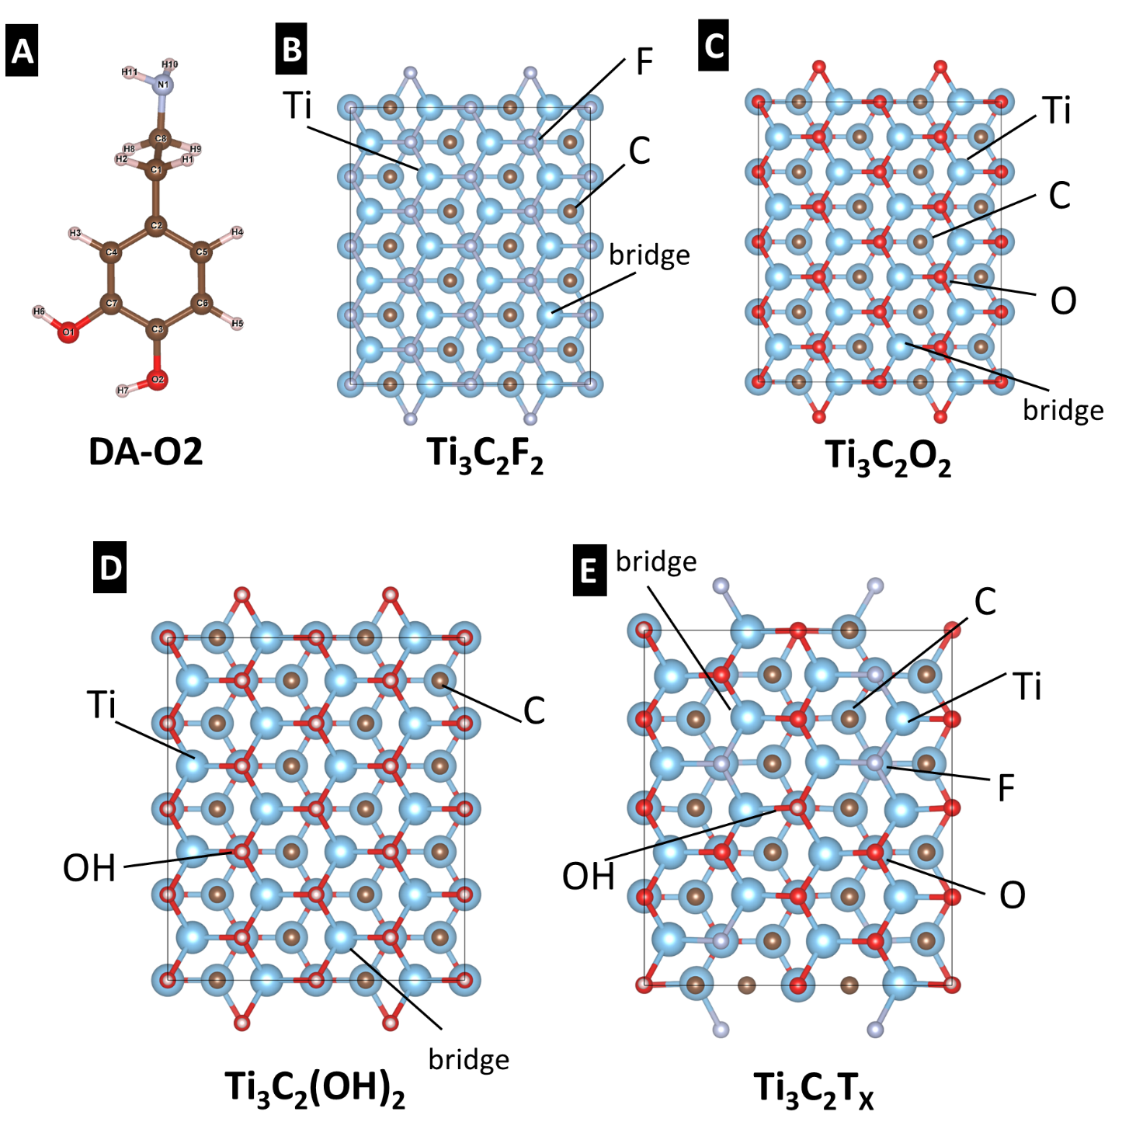
Figure S6. Schematics of atomic models of (A) DA-O2 (B) Ti₃C₂F₂ (C) Ti₃C₂O₂ (D) Ti₃C₂(OH)₂ (E) Ti₃C₂T_{x}

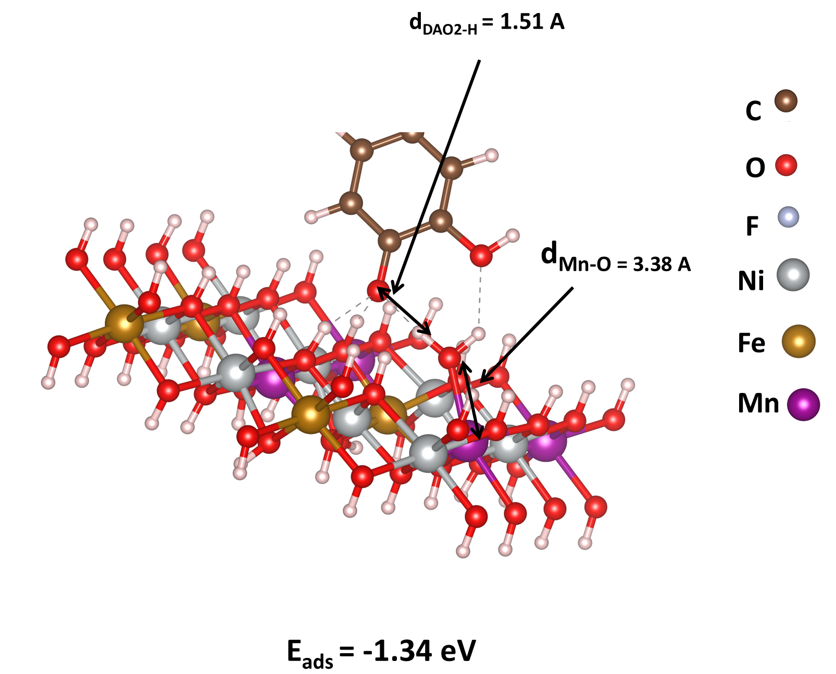

Figure S7: Optimized adsorption configuration of DAO2 on the NFM-LDH bridge site obtained from DFT calculations. Dopamine exhibits strong adsorption with an adsorption energy of −1.34 eV, accompanied by elongation of the catechol O-H bond to 1.51 Å, indicating proton transfer and formation of a catecholate-like dopamine species. The elongated metal–oxygen distance reflects local surface coordination rearrangement during adsorption.

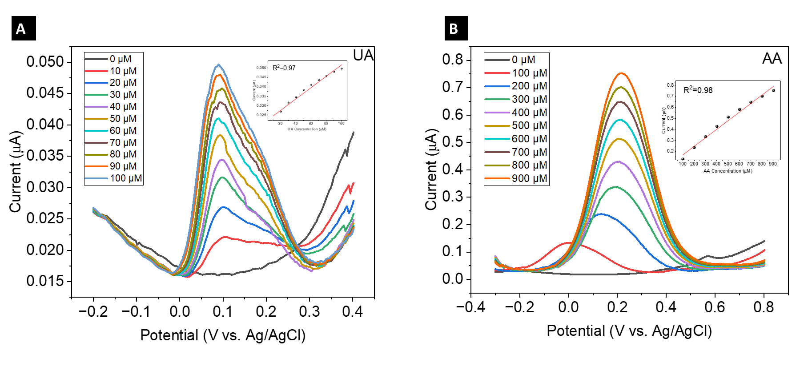
Figure S8. DPV response of (A) UA only and (B) AA only

